**LetsUpgrade Linux Administration Essentials Course Batch 1**

**Assignment Day 5 | 4nd December 2020**

Student Name: Kartick K

Email-id: [kartickkripa@gmail.com](mailto:kartickkripa@gmail.com)

**Assignment:**

1. Add a 10GB disk to the CentOS.

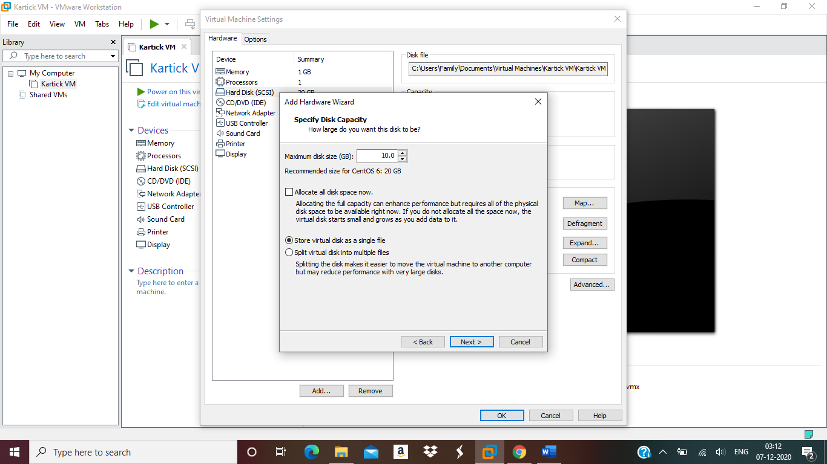

* After adding the 10GB disk :
* 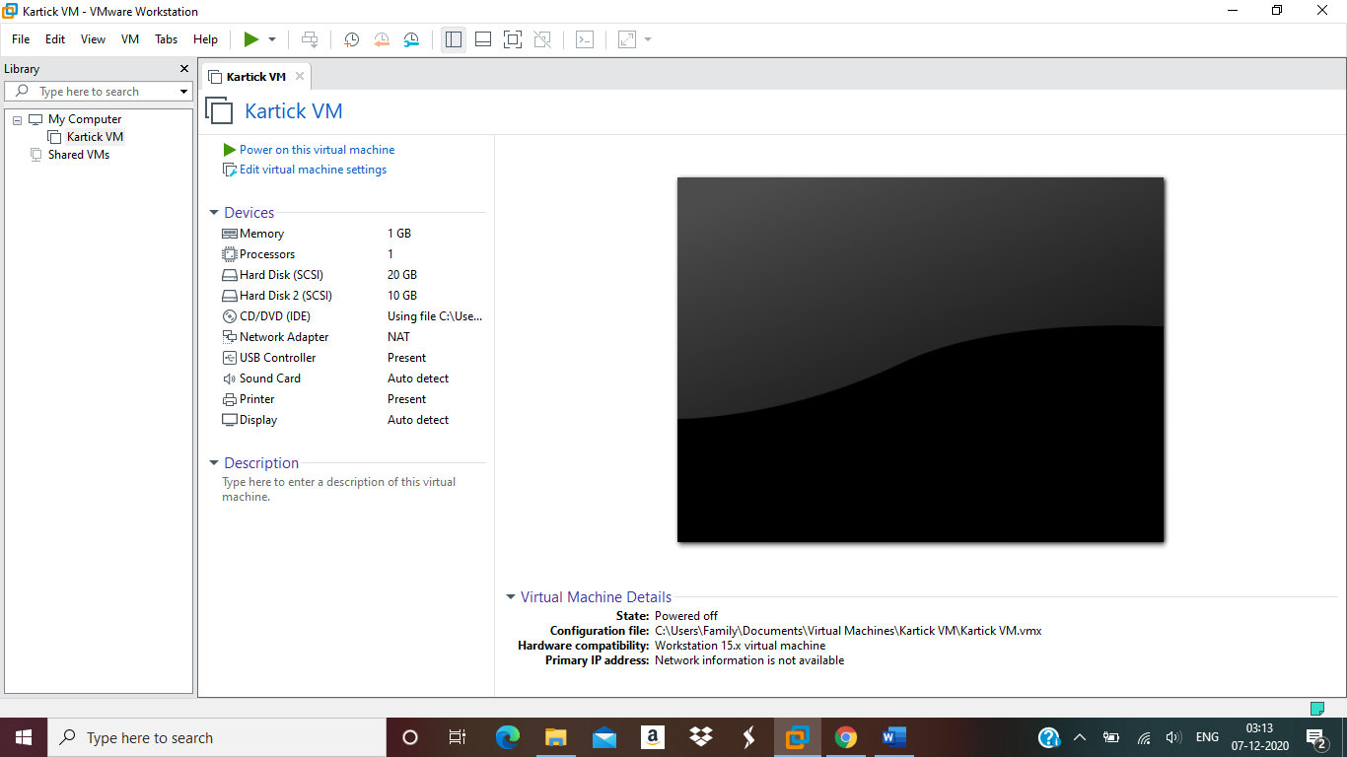
* Initial status of the disk is viewed using lsblk command 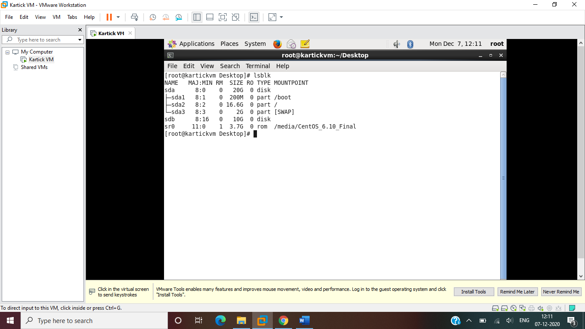

2.Create 2 Partitions 4GB and 6GB of Spaces, respectively.

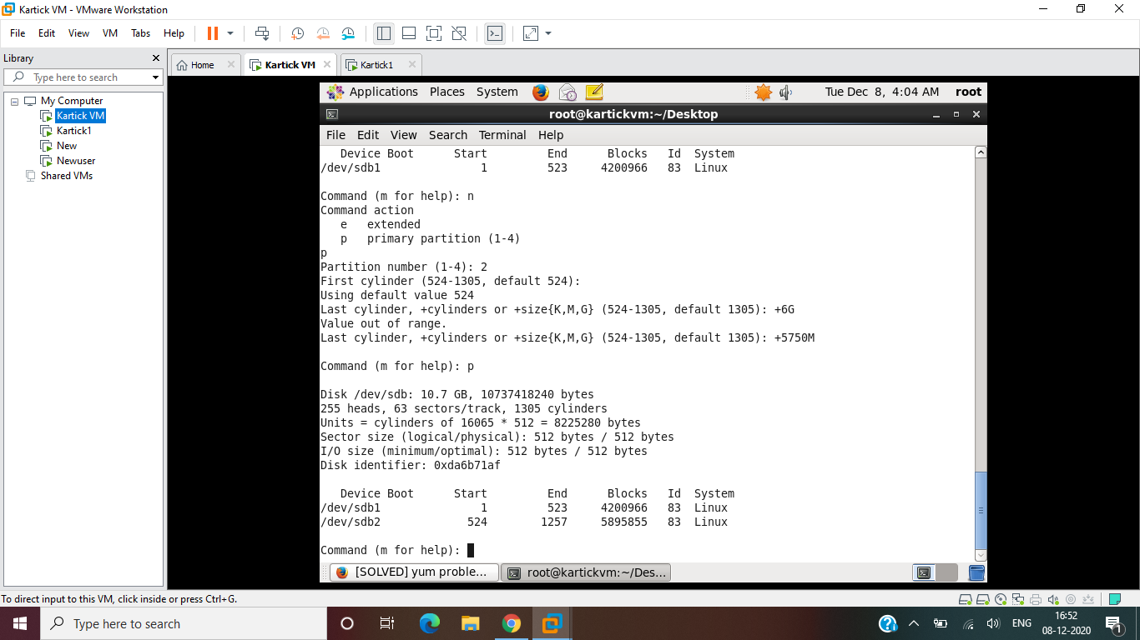

3. Format 4GB with xfs and 6GB with ext4 file system.

* Format the 4GB disk to xfs

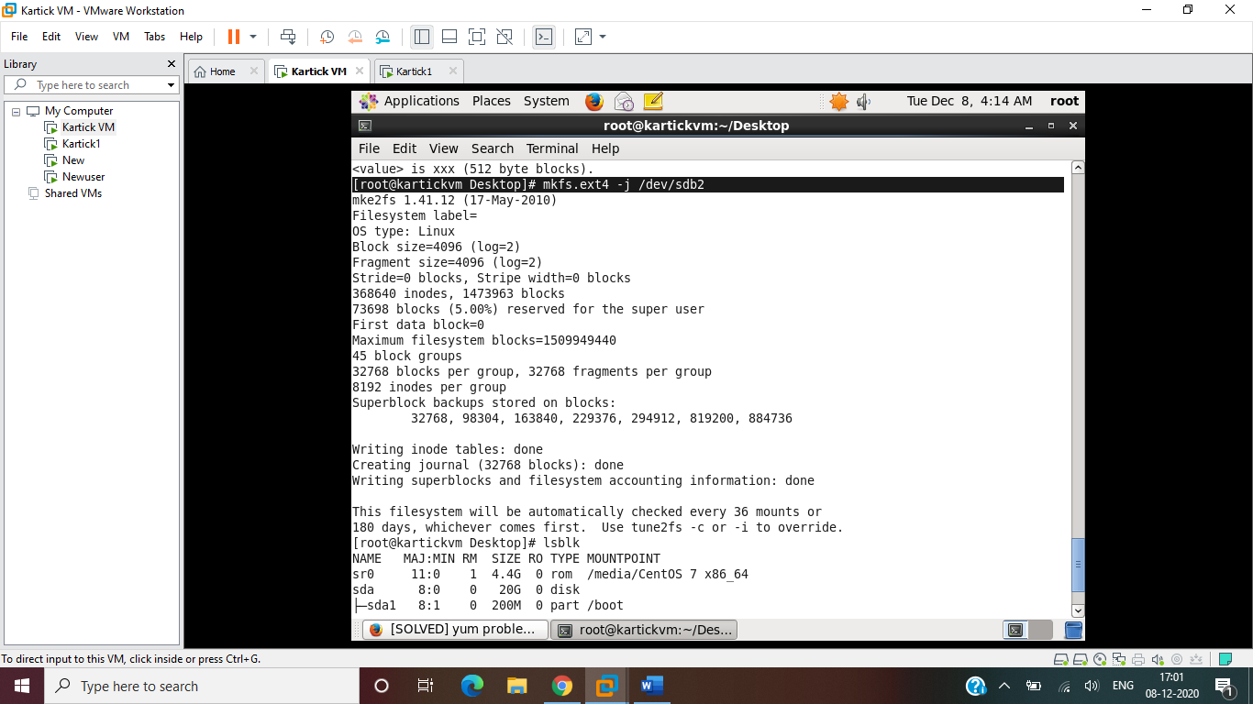

* Formating the 6gb disk(sdb1) to ext4

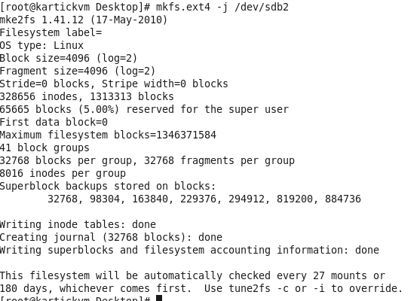

* GUI showing the partition of the disk

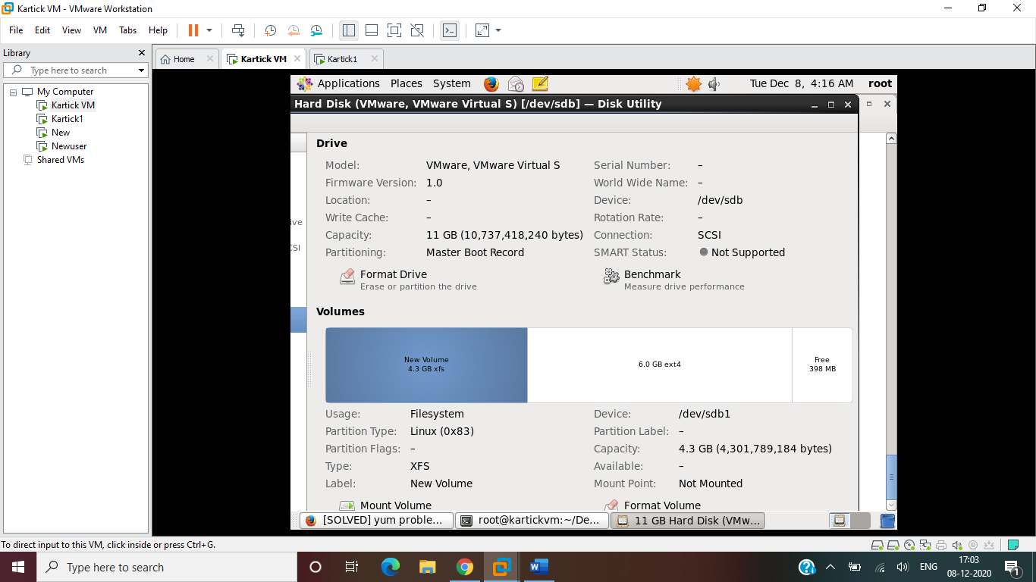

4.Mount 4GB and 6GB in /data and /music directory respectively.

* Create Mountpoint directories

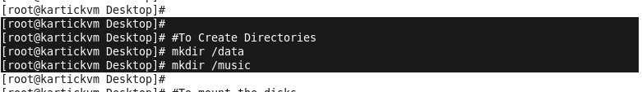

* Mount the disks using the mount command



* Check the mount by using the df -ah command

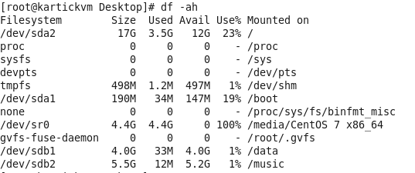

5.Create one file of 1GB in each of the mount point created above.

* For creating 1gb file in /music

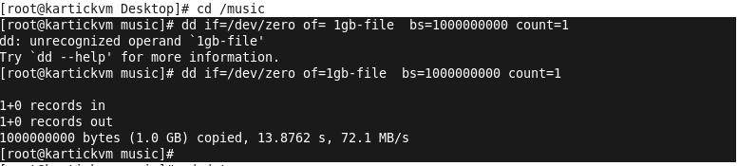

* To create 1GB file in /data directory

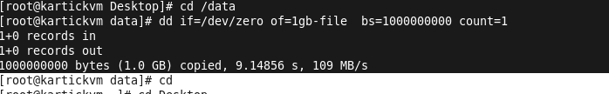

6. Verify the disk Consumption and disk space free in the mounted partitions.

